

**LAB # 5**



**DATED:**

**11th November, 2022**

**SUBMITTED TO:**

**Engr. Rehmat Ullah**

**CSE-202L Digital Logic Design Lab**

**Fall 2022**

**SUBMITTED BY:**

**Ali Asghar(21PWCSE2059)**

**Suleman Shah(21PWCSE1983)**

**Abu Bakar(21PWCSE2004)**

**Department of Computer Systems Engineering**

**University of Engineering & Technology, Peshawar**

ADDERS AND SUBTRACTORS

OBJECTIVES:

* To Design and construct half adder, full adder, half subtractor and full subtractor circuits
* Verify their truth tables using logic gates

COMPONENTS:

* IC’s
  + 7408 Quad-2-Input AND Gate
  + 7432 Quad-2-Input OR Gate
  + 7486 Quad-2-Input XOR Gate
  + 7404 Hex Inverters
* LED’s
* Dip Switch
* 520/1KΩ Resistors

THEORY:

A digital adder circuit adds binary signals & a subtractor subtracts binary signals. Half Adder/Subtractor is a basic circuit that adds / subtracts 2 bits and generates Sum or Difference along with Carry / Borrow. Unlike Half Adder or Subtractor a Full Adder / Subtractor has the provision to take consideration of previous Carry / Borrow also.

LOGIC DIAGRAM HALF ADDER

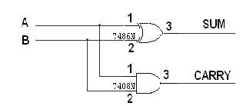

TRUTH TABLE

|  |  |  |  |
| --- | --- | --- | --- |
| A | B | CARRY | SUM |
| 0  0  1  1 | 0  1  0  1 | 0  0  0  1 | 0  1  1  0 |

SUM = A’B + AB’

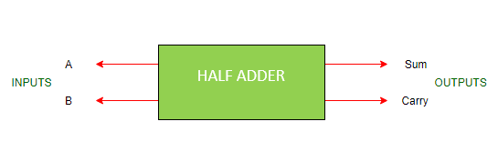

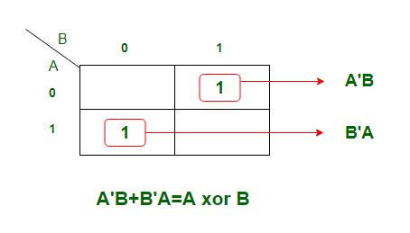

CARRY = AB

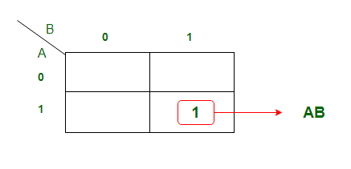

LOGIC DIAGRAM FULL ADDER:

FULL ADDER USING TWO HALF ADDER

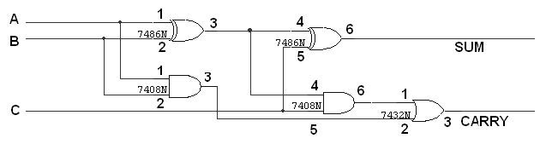

TRUTH TABLE

|  |  |  |  |  |
| --- | --- | --- | --- | --- |
| A | B | C | CARRY | SUM |
| 0  0  0  0  1  1  1  1 | 0  0  1  1  0  0  1  1 | 0  1  0  1  0  1  0  1 | 0  0  0  1  0  1  1  1 | 0  1  1  0  1  0  0  1 |

SUM = A’B’Y + A’BY’ + ABY + AB’Y’ = Y(A’B’+AB) + Y'(A’B+AB’) = YX’+Y’X

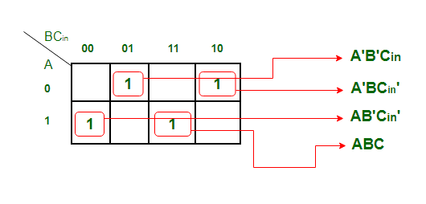

CARRY = AB + BY + AY = Y(A+B) + AB

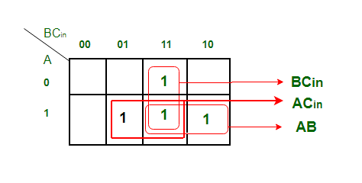

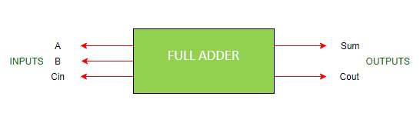

LOGIC DIAGRAM HALF SUBTRACTOR

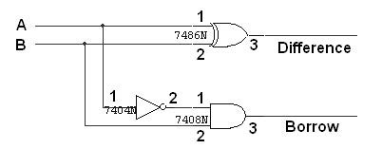

TRUTH TABLE

|  |  |  |  |
| --- | --- | --- | --- |
| A | B | BORROW | DIFFERENCE |
| 0  0  1  1 | 0  1  0  1 | 0  1  0  0 | 0  1  1  0 |

0 – 0 = 0

0 – 1 = 1, borrow 1

1 – 0 = 1

1 – 1 = 0

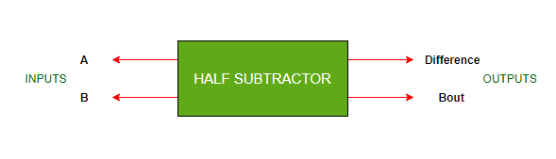

DIFFERENCE= A’B + AB’

BORROW = A’B

LOGIC DIAGRAM FULL SUBTRACTOR

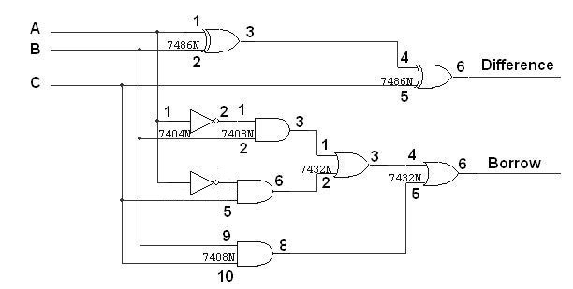

FULL SUBTRACTOR USING TWO HALF SUBTRACTOR

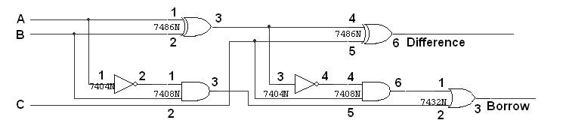

TRUTH TABLE

|  |  |  |  |  |
| --- | --- | --- | --- | --- |
| A | B | C | BORROW | DIFFERENCE |
| 0  0  0  0  1  1  1  1 | 0  0  1  1  0  0  1  1 | 0  1  0  1  0  1  0  1 | 0  1  1  1  0  0  0  1 | 0  1  1  0  1  0  0  1 |

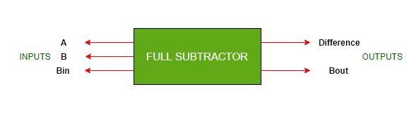BORROW = A’D + BD + A’B = A'(B+D) + BD

PROCEEDURE

1. Connections are given as per circuit diagram.
2. Logical inputs are given as per circuit diagram.
3. Observe the output and verify the truth table.

LAB WORK:

HALF ADDER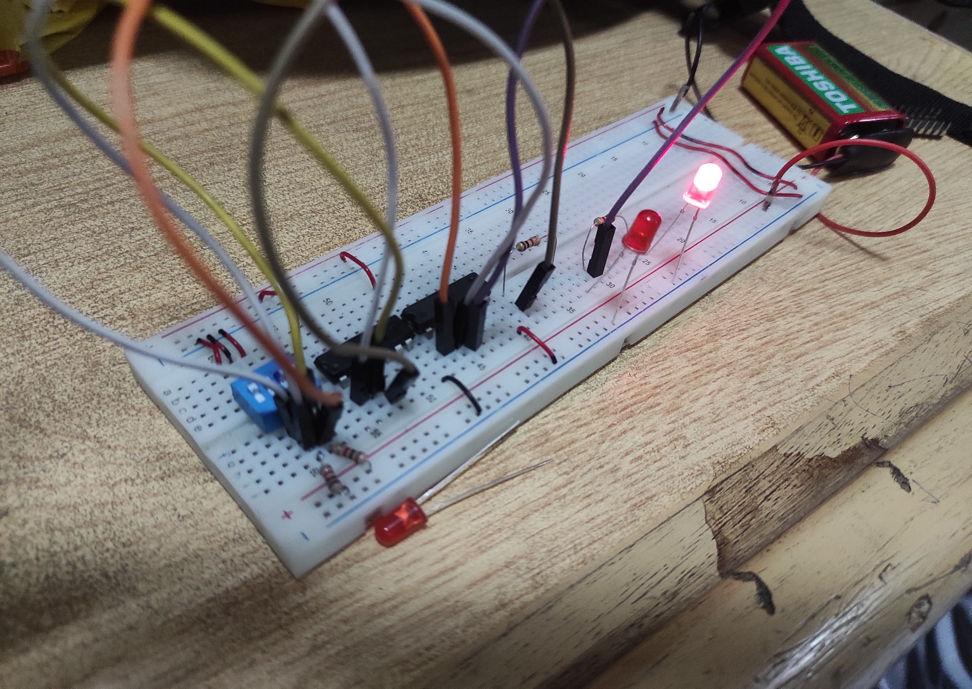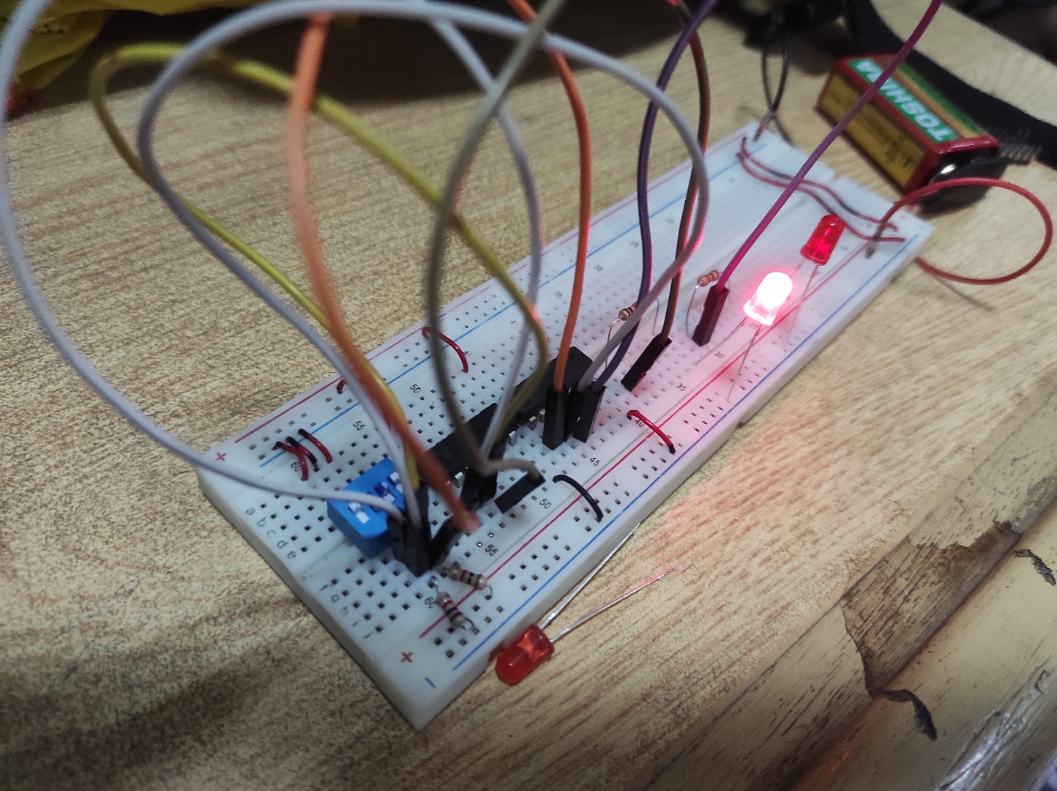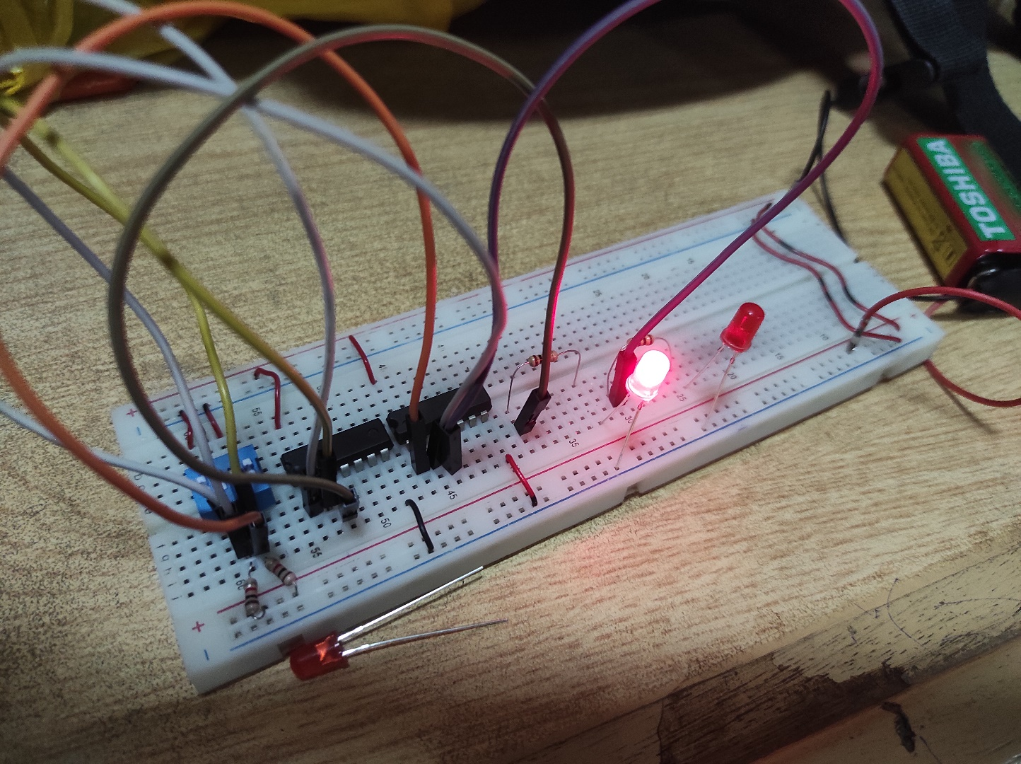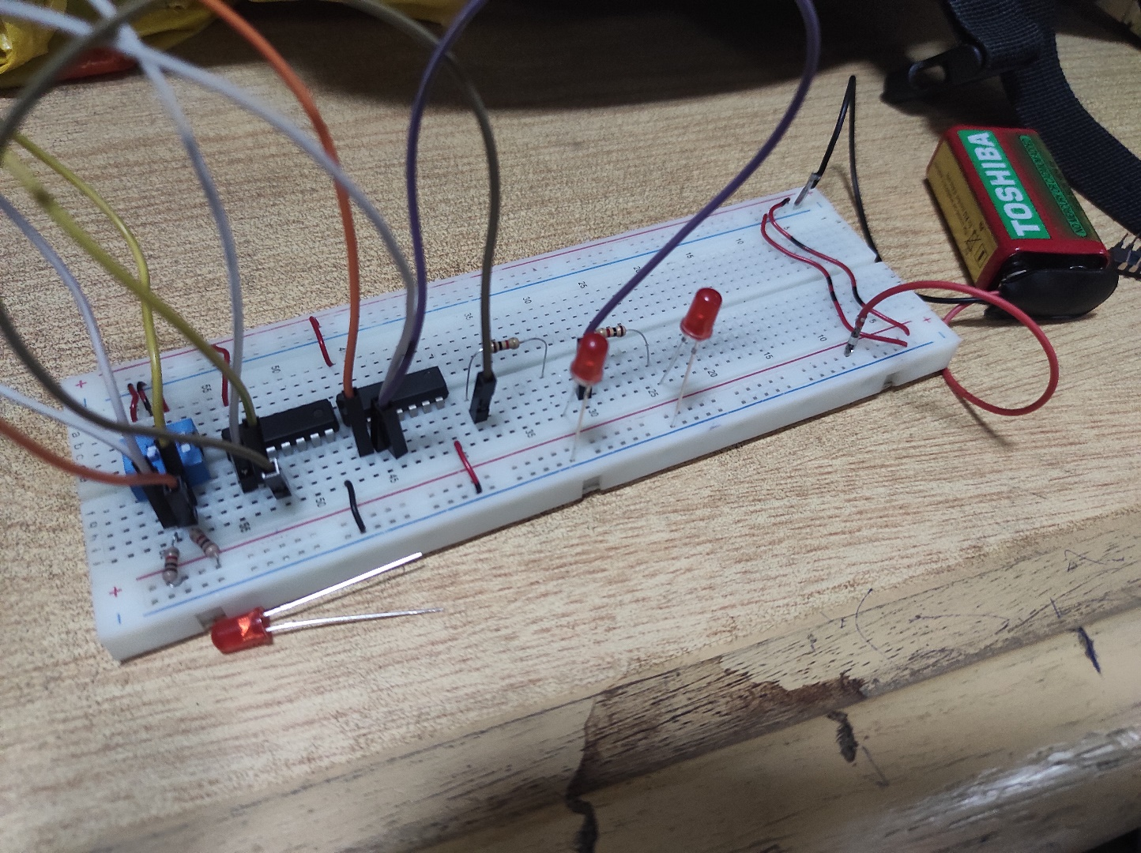

FULL ADDER 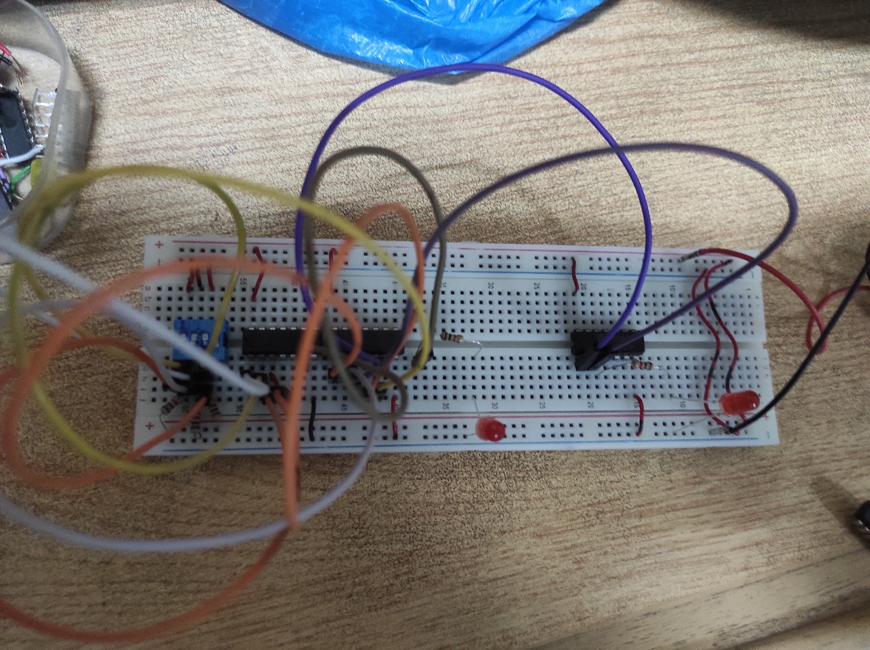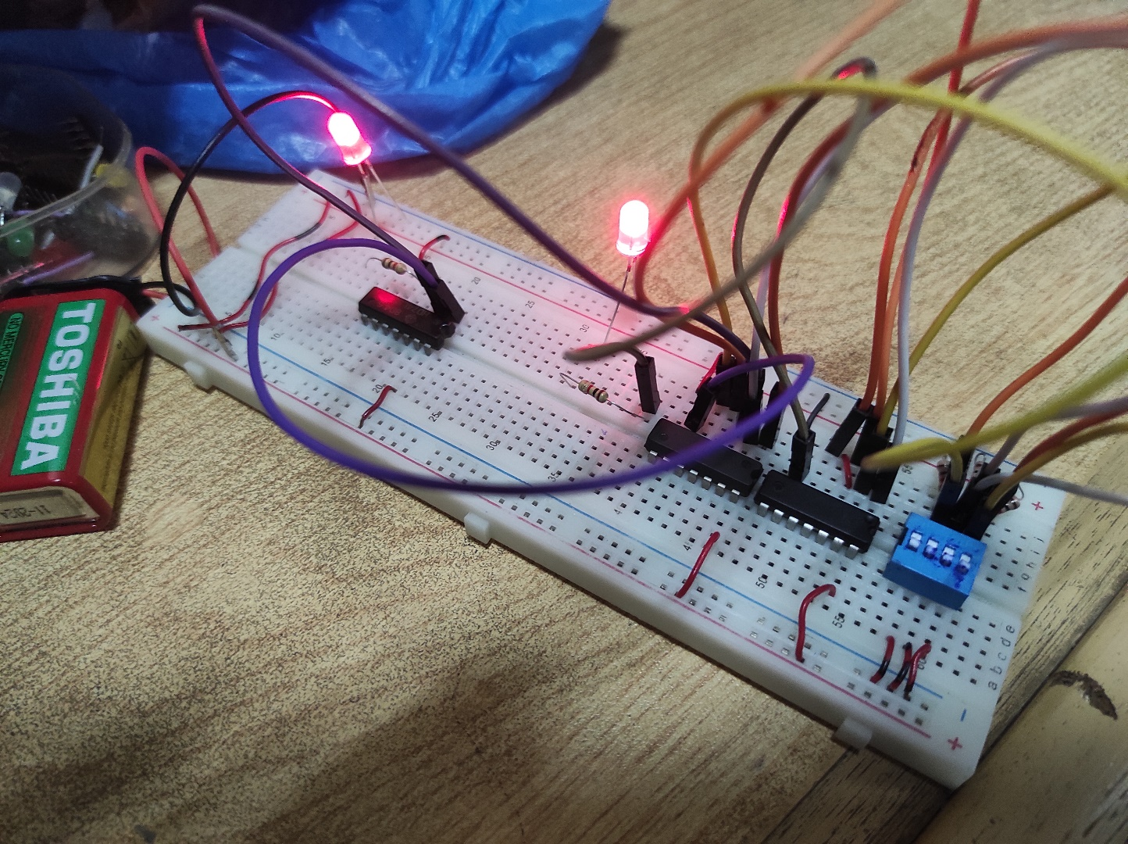

HALF SUBTRACTOR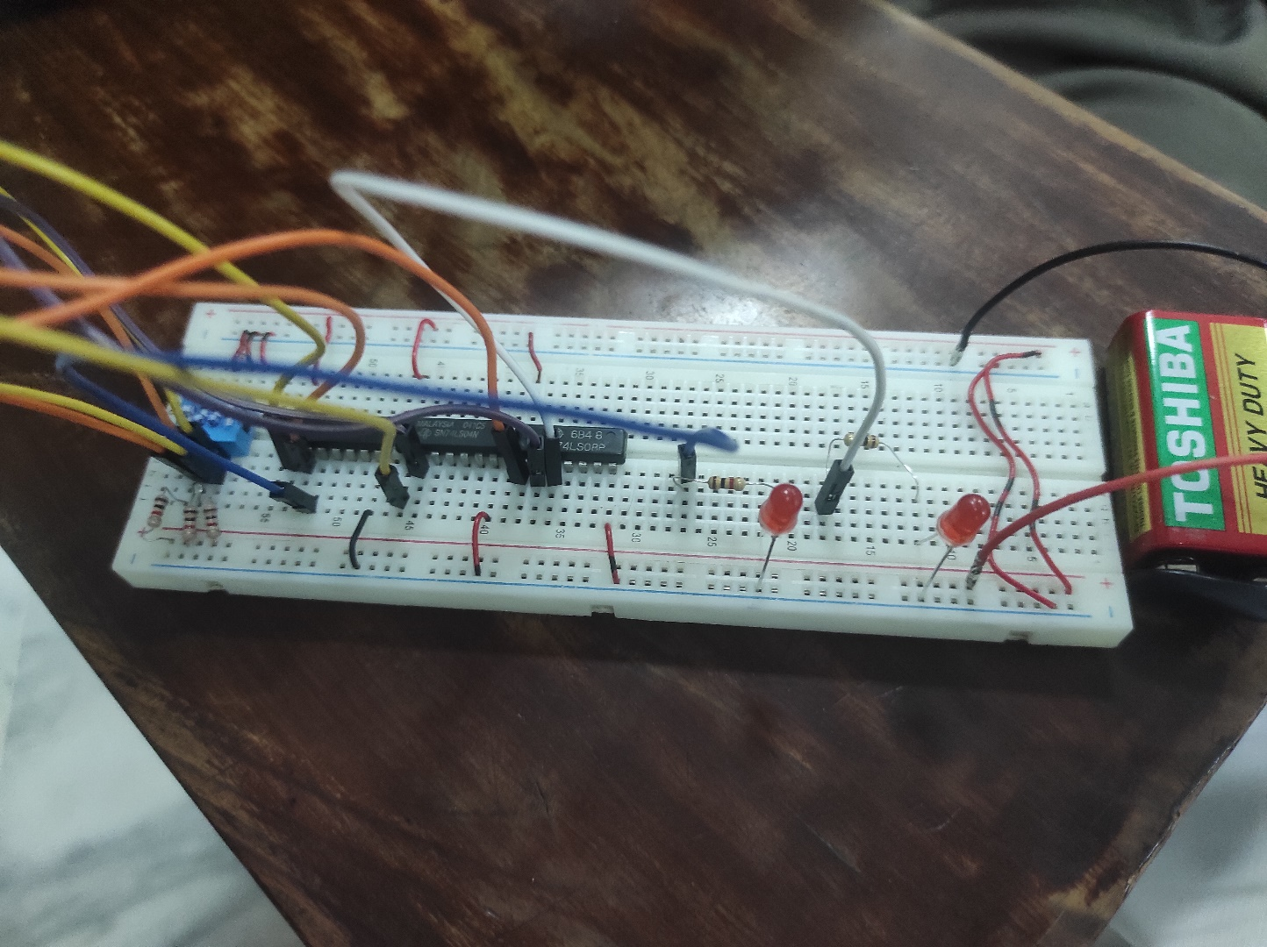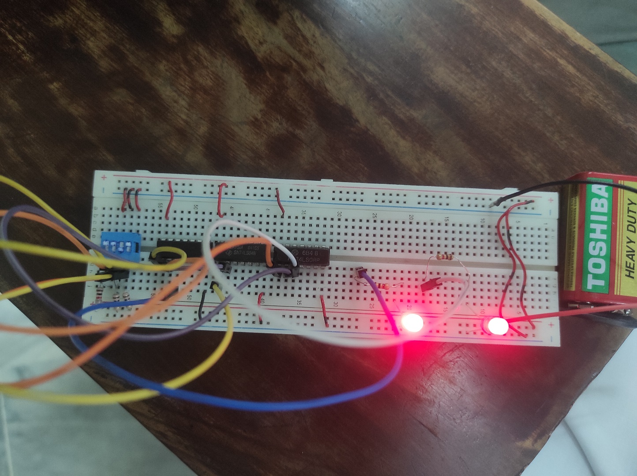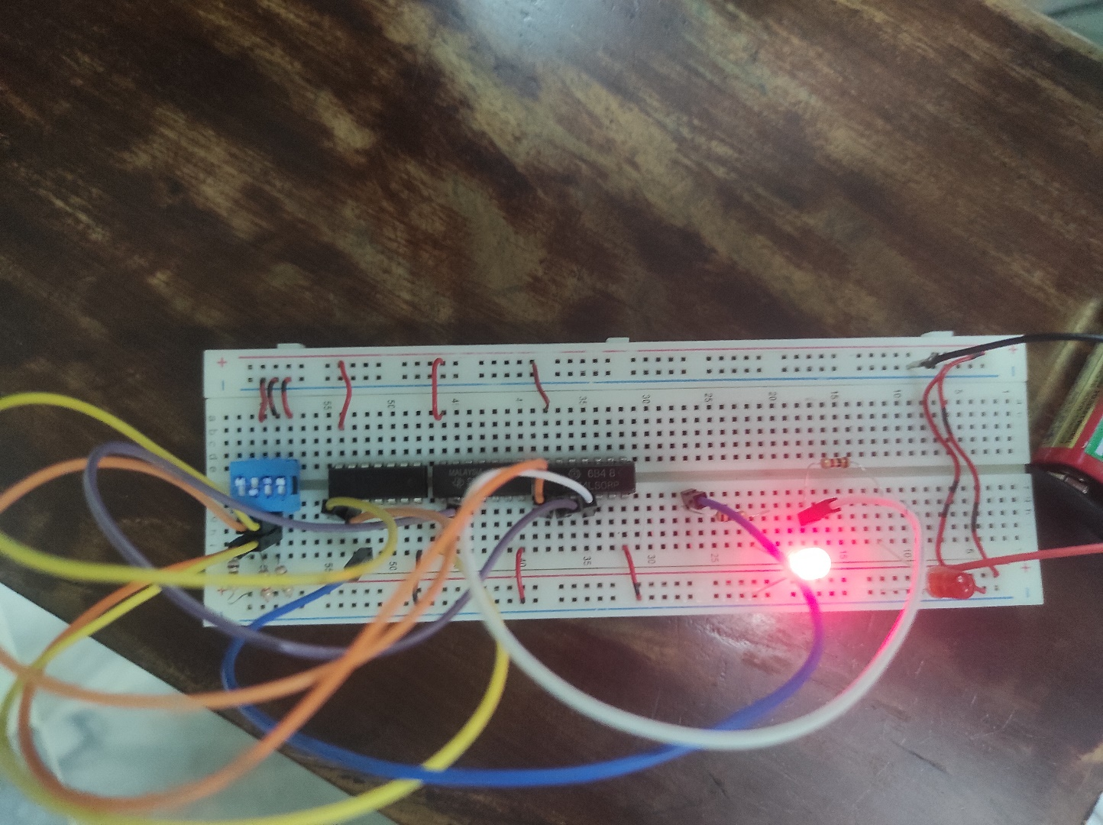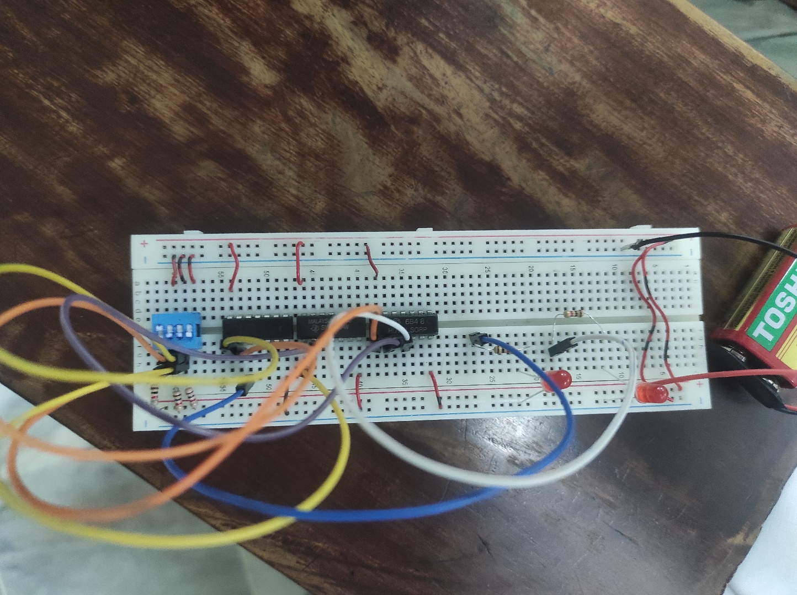

FULL SUBTRACTOR